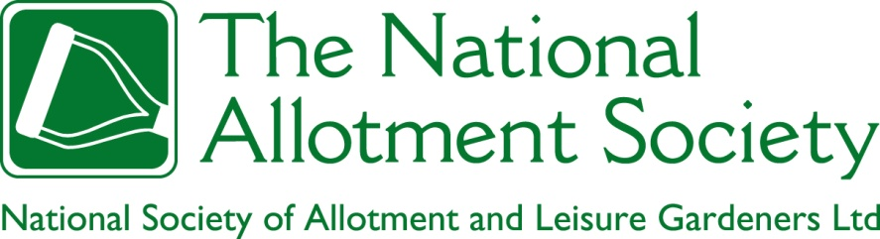

NAS Policy Document 101. Plot Sizes

1. The Society recognises that whilst a maximum size of a holding permitted for an individual is defined by statute, there is no legal definition of the minimum size of an allotment garden, although there are customary standards which have been widely adopted, especially the historic ’10 pole plot’ (c.250 m2). The Society encourages flexible provision of allotment gardens on every site in such sizes (within the legal maxima) which best fit the aspirations and capabilities of present and future plotholders in the locality. The Society recommends the ‘ten pole plot’ (or its nearest metric equivalent of 250m2) as the template for the subdivision of allotment land where appropriate, as something that is well understood, that can be readily and flexibly subdivided on a temporary basis, yet facilitates a clear and economical permanent infrastructure of paths, carriageways and water supply facilities.

2. The Society recognises that a variety of historic units are currently employed in the measurement of allotments and the setting of rents, but endorses the benefits of standardisation on the metric system.

3. The Society recognises that where waiting lists exist, the division of allotment land into large plots can be a source of frustration for those who are waiting, particularly when the plots concerned are not being cultivated to the standard required by the provider. The Society believes, however, that it is unreasonable to expect existing tenants in good standing to surrender all or part of their holding simply to enable providers to reduce waiting lists, particularly when there is no explicit warning in the tenancy agreement of the possibility of a plot size reduction at a later date. The subdivision of plots which have fallen vacant and of a size that is in demand is recognised by the Society as a short-term response to waiting lists, to be undertaken alongside continuing efforts to expand the supply of land available for allotment gardening.

4. The Society recognises that where there is nobody on the waiting list for a plot, there may be opportunities for plotholders in good standing to increase the size of their holdings to more accurately match their aspirations. The Society endorses such upsizing, as being in the best interests both of the plotholders concerned and effective management of the site as a whole, providing that the holdings that result are within the maximum allowable in law.

